**CSI Student Chapter**

**Lateral Thinking**

Lateral Thinking Competition was conducted for a whole day (on 20.08.2019) in which many students from first and second year eagerly participated.**Dr. A. Chamundeswari** helped in motivating the organizers to conduct this completion. She is also in charge of this competition. The chief guest of this competition is Mr. **Bharathi Masilamani**, Sigaram Technologies, Chennai.

This competition consists of three rounds –

1. Aptitude and Riddles
2. Brain Teasers and Mathematical puzzles
3. Competitive programming

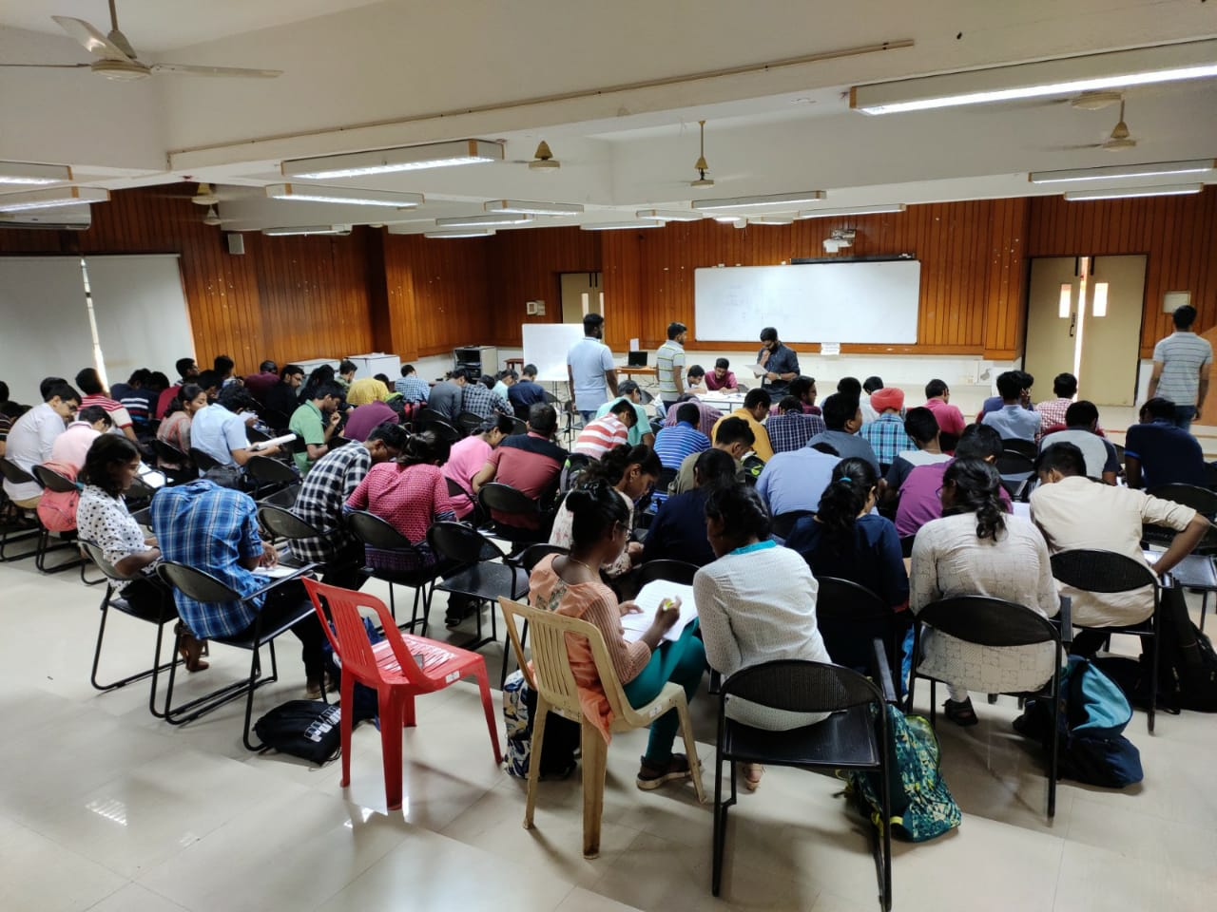

The first round was to warm up their thinking and logical skills. It contained general aptitude questions and logical riddles. This will help them to think logically and proceed with passion.

Nearly fifty two teams participated where, the CSE - Seminar hall was jam packed. General aptitude questions were given in different varieties. Second round was to electrify their neurons and charge them. It was set on a medium-high scale of difficulty. It contained two parts in which the first part, brain teasers were fully related to mathematics. Second part contained math puzzles. Students got boosted up and eagerly waited for the result. Final round was competitive programming. It was an online coding test conducted using the website “HackerRank”. It contained three questions which was set on a medium scale of difficulty. The score is automatically calculated and partial marks were also awarded.

All the levels were timed accordingly. The first round was conducted for an hour, second round was conducted for 2 hours and final round was conducted for 1 hour and 30 minutes.

Almost 15 teams made it to the final round and 3 teams won the competition. The students who got first and second place got internship opportunity in Sigaram Technologies, Chennai.

Volunteering team :

* Krijeshan G.
* Karthikeyan R.
* Bharath Kumar A.M.R.
* Harish Kumar S.
* Hariharan R.
* Aravind P.

Organizing team :

* Level 1 – Mohanram P.B. and Karthik Viswanath S.
* Level 2 – Jyothishmathi C.V. and Mithumary C.M.
* Level 3 – Mohanasundar M. and Pranav Raveendran

By

Mohanram P.B and Karthik Viswanath S